POLICY DEBATE

National and regional partnership plans in focus: the civil society perspective

12 October 2026, 09:30 - 11:00
_____________
Venue: Rue Belliard 101 – 1040 Brussels
Meeting room: JDE 63
Code: 12PD263898
Moderator: |  | ELENA ALEXANDRA CALISTRU  President, ECO Section, European Economic and Social Committee
Speakers: |  | SERAFIN-PAZOS VIDAL  Policy Expert on AEIDL (European Association for Innovation in Local Development)  CARLOTTA BESOZZI  Director, CIVIL SOCIETY EUROPE  RENATA CALAK  Director of the Department of Strategy at the Ministry of Development Funds and Regional Policy, POLAND  Eliza BARNEA - Policy Advisor for Friedrich Ebert Stiftung's Just Climate Competence Center
Languages: EN/FR/ into EN/FR/

OUR SPEAKERS
ELENA ALEXANDRA CALISTRU
President, ECO Section, European Economic and Social Committee
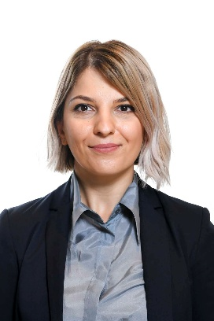
Elena Calistru is serving as member of the European Economic and Social Committee on behalf of civil society, where she is the President of the ECO Section. She has focused in her work on issues related to public finance, including the Multiannual Financial Framework, the Recovery and Resilience Facility or cohesion policy. With over 20 years of experience in civil society projects, Elena's expertise spans good governance, public finance, and advocacy, making her a leading voice in efforts to create a safer, well-informed society. Elena Calistru is the founder and chair of Funky Citizens, a Romanian NGO that promotes government accountability and transparency through research-based advocacy tools & citizens mobilization.

SERAFIN-PAZOS VIDAL
Policy Expert on AEIDL (European Association for Innovation in Local Development)
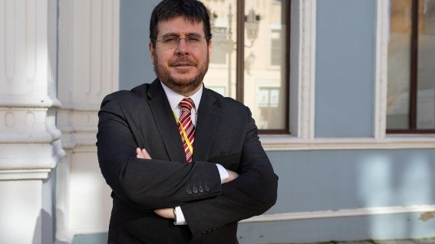
- Senior Policy Lead, Territorial Cohesion at the European Association for Innovation in Local Development (AEIDL) in Brussels.
- Former Head of EU Policy for the COSLA (Convention of Scottish Local Authorities).
- Academic background holding a PhD in European Union Law specializing in subsidiarity, multilevel governance, and intergovernmental relations.
- Expert in EU Cohesion Policy & Regional Development: In-depth knowledge of EU funding mechanisms, territorial cohesion, and Article 174 regions (areas with geographic or demographic challenges).
- Rural & Local Governance: Policy research on rural revitalisation, urban development, and sub-national administration engagement.
- Multilevel Governance & Subsidiarity: Author and active academic contributor on how local and regional authorities participate in EU decision-making.

CARLOTTA BESOZZI
Director, CIVIL SOCIETY EUROPE
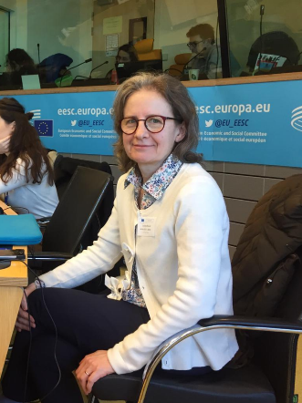
• Managing a network of European platforms of civil society organisations representing different policy sectors and groups
• Strategy and campaign development
• Coordination of advocacy work on civic space, Civil dialogue, rule of law and fundamental right, democracy, future of Europe, funding
• Representation towards EU institutions
• Keynote speaker at European conferences and events
• Coordination and Participation in EU projects
• Management of the Secretariat
• Fundraising and management of finances

RENATA CALAK
Director of the Department of Strategy at the Ministry of Development Funds and Regional Policy, POLAND
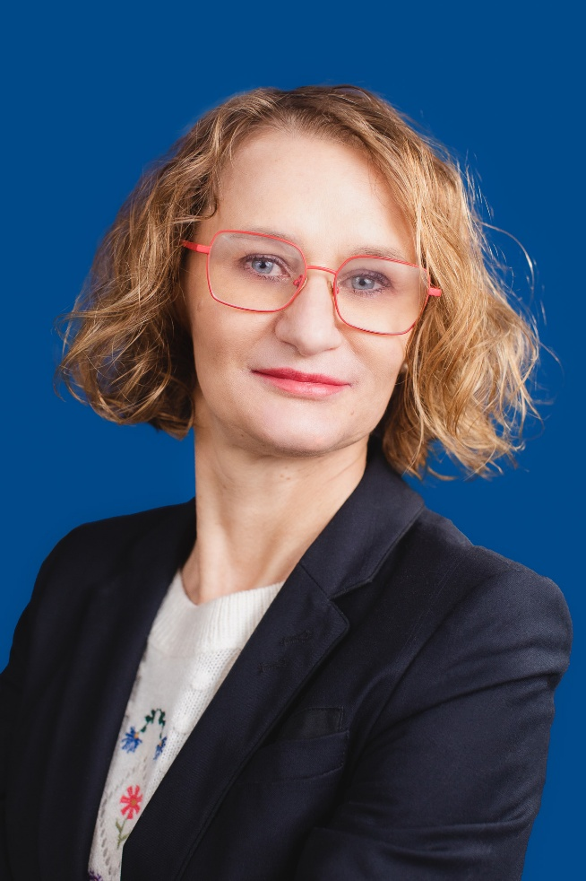
PhD in Economics, Director of the Strategy Department in the Ministry of Funds and Regional Policy. She coordinates development policy, the process of preparing and monitoring development strategies, the implementation of development strategies, as well as the evaluation of European and national policies. She is responsible for coordinating the preparation of the National and Regional Partnership Plan, strategic coordination of the Partnership Agreement, development of cohesion policy solutions in the 2014-2020 and 2021-2027 perspective, implementation and monitoring of regional and urban policy, within the framework of the National Regional Development Strategy 2030 and the National Urban Policy 2030, and the National Recovery Plan. She participated in the preparation of legal acts providing a framework for the effective absorption of Structural Funds and the Cohesion Fund, as well as national measures supporting regional development, such as the Act on the Principles of Development Policy. She coordinated work related to Poland's Presidency of the Council of the EU in the field of cohesion policy. She participated in the preparation of a number of strategic documents at the national level, such as: the National Development Strategy 2007-2015, the National Regional Development Strategy 2010-2020, the National Spatial Management Concept 2030, the Strategy for Responsible Development, the National Regional Development Strategy 2030 and the National Urban Policy 2030.
Eliza BARNEA
Policy Advisor for Friedrich Ebert Stiftung's Just Climate Competence Center


CEE Bankwatch Network
Grant management for just transition centered activities in the Romanian regions benefitting from the Just Transition Mechanism
Design, implement and evaluate projects to increase local capacity and public participation in the just transition process in Romania, including support in technical assistance streams
Design, implement and evaluate the just transition advocacy campaign, promote just transition principles and propose synergies with other EU instruments
Policy analysis and recommendations to improve national/ EU just transition & energy poverty policy frameworks
Represent Bankwatch Romania in the Monitoring Committee for the Implementation ofthe Just Transition Fund at the Ministry of European Investments and Projects
Facilitate collaboration between stakeholders at local, national and European level andact as main focal point for CEE Bankwatch Network in Romania

