 |  | 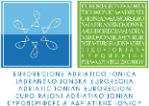 |  |  | 

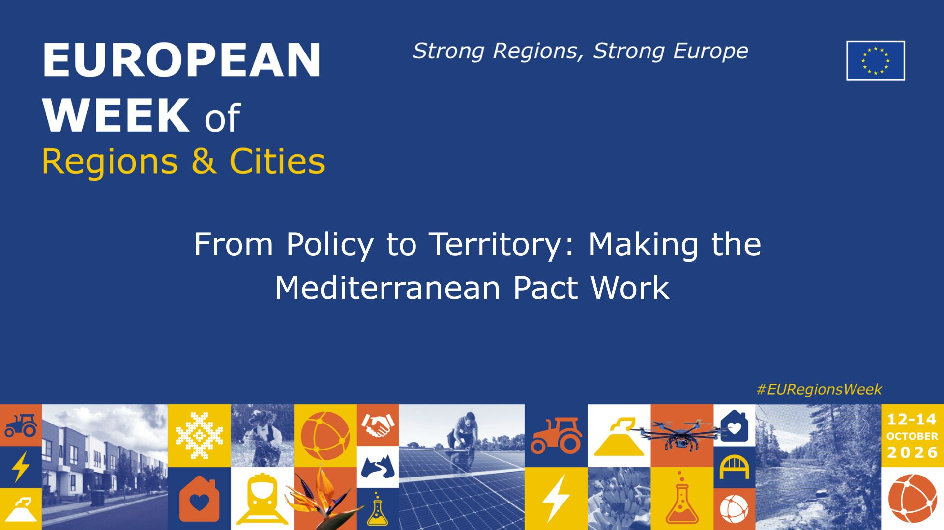

Led by the Government of the Balearic Islands and organized by the Med Cooperation Alliance (Euroregion Pyrenees Mediterranean, Adriatic Ionian Euroregion, MedCities, Conference of Peripheral Maritime Regions and Generalitat de Catalunya)

Wednesday, 14 October 2026
Brussels

Time: 11:00 – 12:30 CET

Format: Policy Debate

Square Brussels Convention Centre – Rue Ravenstein 2, Brussels
Studio 314+316
Room Capacity: 100 people
Interpretation: English, Spanish and Italian

AGENDA

Introduction
11:00 - 11:05 - Margalida Prohens, President of the Government of the Balearic Islands and President of the Pyrenees-Mediterranean Euroregion
11:05 – 11:10 - Jaume Duch, Regional Minister of the Government of Catalonia and Vice-President for Neighbourhood of the CPMR

Panel Interventions
- 11:10 – 11:20 - Aldrin Dalipi, President of the Tirana Regional Council and President of the Adriatic-Ionian Euroregion
- 11:20 - 11:30 – Marie-Antoinette Maupertuis, President of the Assembly of Corsica and Co-rapporteur of the ARLEM opinion on the action plan for the Pact for the Mediterranean
- 11:30 – 11:40 - Clare Hart, Vice-President for International Relations of Montpellier Métropole Méditerranée and Acting President of MedCities
- 11:40– 11:50 - Margalida Prohens, President of the Government of the Balearic Islands and President of the Pyrenees-Mediterranean Euroregion
Debate
- 11:50 – 12:00 - Jaume Duch, Regional Minister of the Government of Catalonia and Vice-President for Neighbourhood of the CPMR
- 12:00 – 12:25 - Interactive discussion with the audience, with the contributions of Francisco Gaztelu, European Commission Director for North Africa, and Sébastien Viano, Deputy Director General of the Directorate-General for Europe, Mediterranean and International Cooperation of the Provence-Alpes-Côte d’Azur Region
Closing
- 12:25 – 12:30 - Jaume Duch, Regional Minister of the Government of Catalonia and Vice-President for Neighbourhood of the CPMR

