Session: Taking the Next Step in Shaping Europe’s Rural Future with the Long-term Vision for Rural Areas
- What is crucial to leverage rural development and wellbeing in rural Europe?
- What priorities do you see when it comes down to measures?
Challenges lie ahead for transforming the European Commission’s ‘long-term vision for rural areas’ into a reality for rural areas. How can EU institutions support national and subnational actors in overcoming identified challenges? The P10, the association for rural municipalities in the Netherlands hosted the participatory lab as part of the main programme of the European Week of Regions and Cities in Brussels. Under the title ‘Taking the Next Step in Shaping Europe’s Rural Future with the Long-term Vision for Rural Areas’, Ellen Nauta Chairwoman of P10 and mayor of the Dutch rural municipality of Hof van Twente and member of the Committee of Regions and cities moderated the session providing an interactive space to debate long term wellbeing with the most critical measures to take. A diversity of experiences from different perspectives in practice kick started the discussion.
Silvia Nanni, Policy expert of the European Commission, DG AGRI highlighted the contributions of EU funding to rural areas and shared her insights on strategies for enhancing financial support for rural areas. She elaborated on key achievements and ways forward. EU funds have played a significant role in developing rural areas by supporting infrastructure, economic growth, and community initiatives. However, the effectiveness of this support varies in each region.
Bettina Bock, Professor of inclusive rural development, Wageningen University in the Netherlands shared her insights and experience based on research, comparing international policies for maintaining basic services in rural areas. Maintaining services is important for the future of rural areas and it requires different policies than those for urban areas. She advocated for tailored regulations and funding, adapted to the reality of the region and rural area.
Ben van Essen, Vice President European Rural Community Alliance (ERCA) and member of the Rural Pact Coordination Group gave an explanation on the achievements of the Rural Pact in their efforts to bring the LTVRA closer to the citizens and empowering citizens initiatives. He emphasized the key elements, or ingredients, needed to mobilize stakeholders around the Rural Pact and foster concerted action towards meeting the objectives of the long-term vision for the EU’s rural areas.
Starting from the speakers insights participants were invited to share their perspective and discuss ideas to support the effectiveness of EU policy for rural areas, below the resulting actions:

Report on group discussion about EU funding for rural areas
Facilitator: Silvia Nanni - European Commission, DG AGRI
Focus: Enhancing EU funding access for rural areas
Overview
This session explored the current contributions of EU funding to rural areas and examined strategies for enhancing financial support in the future. Participants discussed the available tools (notably the Rural Toolkit on EU funds) ways to streamline administrative procedures, improve funding accessibility, and address the specific challenges facing rural communities.
Three central questions guided the discussions:
- How are EU funds currently contributing to rural development?
- How can financial support for rural communities be enhanced through EU, national, and regional funds?
- What improvements are needed to simplify access to funding for beneficiaries?
Current impact
EU funds have played a significant role in developing rural areas by supporting infrastructures and basic services in rural areas, economic growth and diversification, and locally-led community initiatives. However, the effectiveness of this support varies in each country and region in Europe.
Challenges in rural areas
- Quality of life: Limited access to essential services such as healthcare in rural areas affects residents' quality of life. Addressing these issues is key.
- Capacity constraints: Many rural communities struggle with insufficient capacity, which hampers their ability to secure and manage EU funding effectively. Limited administrative capacity in rural areas often restricts their ability to participate fully in projects and secure funds. Enhanced support and capacity building for local authorities and communities to navigate funding opportunities is necessary to improve rural participation.
- Population: Retaining residents and attracting new residents is a challenge, which needs to be overcome.
- Support: Additional assistance is needed for local leaders, such as mayors who may not speak English, to ensure effective participation.
Key take aways
- There is potential to further leverage the Rural Toolkit to help rural areas identify funding opportunities, find partners, and navigate the complexities of the funding landscape.
- The Rural Observatory serves as a valuable data hub for rural regions, bringing together data that supports evidence-based policymaking and enhances rural areas' ability to communicate their specific needs effectively.
- Simplifying EU funding rules, reducing administrative burdens, and enhancing procedural flexibility are seen as essential steps for supporting participation from rural communities.
- Quicker fund movement and increased accessibility are also needed. An innovative idea that was shared, was to provide funds directly to contractors or suppliers, bypassing intermediate administrative layers. This could reduce costs and speed up project completion.
- Active local authorities play a vital role in securing funding, driving rural development projects, and supporting local initiatives to ensure that community needs and opportunities are effectively addressed.
- To maintain wealth and services in rural areas, it is essential to gather insights on the local strengths and weaknesses, which can inform policies designed to support and enhance community assets.
- Local leaders are essential. We need to mobilise and support leaders and keep them in the areas.
- A holistic and cohesive approach is needed across EU, national, and regional governments to support rural development and rural communities.
- Local action groups can play a key role in mobilising resources, engaging communities, and implementing projects that address local needs.

Report on group discussion The importance of basic services for rural development
Facilitator: Bettina Bock, Wageningen University
Focus: Maintaining basic services in rural areas
Three central questions guided the discussions:
1. Why should we maintain basic services in rural areas?
2. Who is responsible for maintaining basic services?
3. What can best be done?
Overview
Availability of Internet:
- Depopulation in Italy one of the reasons is because internet is not good enough to work there (adsl)
- A good internet would help to invite people to move to rural areas
- Internet helps to maintain basic services. For example a village has a doctor for two days physical and the other days you can ask your questions remote via internet consultation
Cooperation between local businesses and rural citizens (in Sweden):
- The culture / government: rural areas have to help themselves. This is changing.
- When the forest in a region a mainly privately owned this helps in the basic services level in that region. For example they ask local businesses to help them maintain their forests.
Public services that offer something else / innovative
- It might help if public services in rural areas offer something different than the urban areas. For example in Spain there is a rural village that offers Montessori education. This helped to attracted new families.
Basic services as a means for looking after each other as a meeting place
  - Residents take over. Not in all countries. We see it a lot in the Netherlands
  - Examples are: neighborhood car with volunteers to help drive around the elderly people, or a supermarket run by volunteers. In Italy there is pharmacy where a volunteer help to distribute medicines to old people in the region.
  - In most countries basic services are mostly run by public or businesses, not civic (volunteers).
  - Norway is also a volunteer country. There they see that more and more young people are involved.
Lack of capacity building and knowledge to reach vitality in rural areas
- In regions as in Italy and Spain there is a lack of capacity and knowledge to work on a better vitality in rural areas.
- There is not a lot of attention from national governments for rural areas. It has become a bit more since covid.
Rural Proofing
- Not a lot of experience in Europe
- Netherlands ministry LVVN is starting with rural proofing
- Spain is a law but not yet in practice
Interesting project:
- ORTEGA-REIG

Report on group discussion about bringing the LTVRA closer to citizens
Facilitator: Ben van Essen, member Rural Pact Support office
Focus: Empowering local communities to achieve Europe’s rural vision
Central question: How can we bring the LTVRA closer to the citizens?
Overview
At the Subgroup-table “concrete ideas were exchanged.
- The Rural Roadmap; In line with the ingredients outlined in the Policy Briefing of the Rural Pact (Making the Rural Pact happen in Member States : Link) the following roadmap should be followed in the regions, supported by the EU/RPSO (example Catalonia), for the LTVRA to land in the EU-Countries,
  - Create a national/regional holistic long-term vision, not under the direction of the Ministry of Agriculture but under the direction of the government, covering the full spectrum of rural issues.
  - Create an action plan to implement the vision;
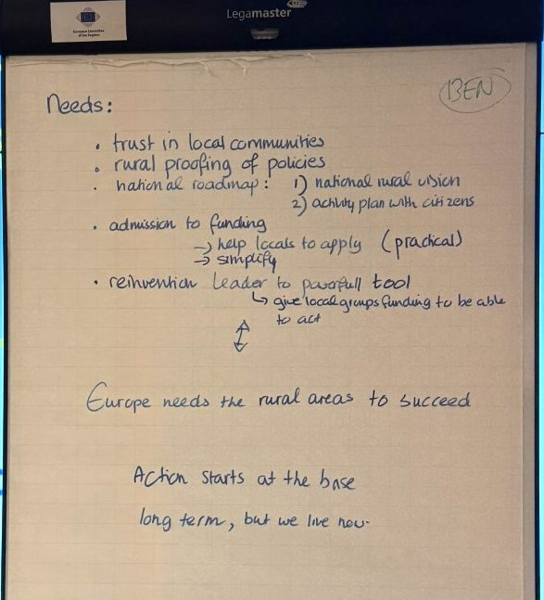
  - Bring together all parties required for the action plan in an Rural Pact;
  - Organize the implementation including finance.
- A National Helpdesk for Funding; Financed by the EU (!!), a Funding Helpdesk should be established in each Member State, where concrete support is provided in applying for EU subsidies. Both in the EU and in most countries there are websites with information about funding. There is even an Rural Funding Toolkit. But that is not enough for initiatives, certainly not the bottom-up initiatives, to find their way in the funding jungle. They need a phone number, a person to help them formulate the question(s) properly and then go through the funding-procedure. Commercial consultancies are not a good alternative.
- Reduce Administrative burden; It is also necessary to significantly reduce the administrative burden of applying for EU contributions. Applying for (and accounting for) relatively small contributions entails a disproportionate administrative burden that is out of proportion to the financial resources and is also very discouraging.
- Capacity building/reinventing Leader; To strengthen bottom-up initiatives, appropriate support is needed. This requires the deployment of trained support staff and therefore Capacity Building. Put in place a mechanism to give local communities possibilities to enhance their capacities to implement initiatives (particularly in those communities lagging behind) by supporting them in:
- the identification and development of technical projects in all possible thematic areas that contribute to the vision and relevant for the local areas (energy, mobility, health, etc).
- the identification of funding available for their initiatives and the technical know-how to apply for them
All the above could be done in different ways in different places, for instance:
- Through LEADER and other local development structures by giving them additional finance to cover the costs incurred in the technical preparation of projects – in EU jargon is used as “preparatory support”.
- A helpdesk to support the identification of funding and support how to apply for them.
LEADER and other local development structures could enlarge their roles as also local development agencies rather than only as a window to distribute EU funding (which is also needed). The LAGs could develop into drivers and supporters of initiatives. As they do not have the capacities for that now, there should be a program of Capacity Building. Leader is also still too tied to the CAP framework and should go beyond that.
A lot of rural regions are not connected to a LAG. Organizations such as ERCA have a much more refined network and thus reaches out to a much larger part of the living environment of rural resident. A Capacity Building program could also be linked to ERCA to even better support the development of local initiatives.

Quotes:
Silvia Nanni: “Europe is open to listen about how we can better contribute to supporting rural areas - and we consider rural areas extremely important. With their human and social capital, with their nature and beauty, with their traditions, and generally, with their overall potential to make our continent an even better place to live”.

Bettina Bock: “Tailored regulations and funding are needed, adapted to the reality of the region and rural area”.

Ben van Essen: “Rural change cannot be achieved without the strong involvement of local communities”.

